|  |  |  |  |  |  |
| --- | --- | --- | --- | --- | --- |
|  | **Alam Afrooz Production and Engineering Company** | | | | AlamAfroze Co. |
|  | Title Deed Number | Quality Control Guidelines | Title of the document | Page:1 of 23 |
|  | Date |  | Revision Number |

Quality Control Guidelines

Alam Afrooz Company

|  |  |  |  |  |  |
| --- | --- | --- | --- | --- | --- |
|  | **Alam Afrooz Production and Engineering Company** | | | | AlamAfroze Co. |
|  | Title Deed Number | Quality Control Guidelines | Title of the document | Page:2 of 23 |
|  | Date |  | Revision Number |

**1-Introduction**

In Quality Management, Engineering and Industrial Production, Quality Control and Quality Engineering

It is said that a section is engaged in making methods so that the factory can use those methods to improve the quality and

Ensure that the products are customer-friendly.

Quality control is a set of operations such as measurement or testing that is performed on a product or commodity to

It should be determined whether the product meets the desired technical specifications or not.

The main issue of quality control is related to sampling of products, inspection of those samples and generalization of the results to the total accumulation

It is a product that is done based on statistical methods. Other methods used in quality control are

The product production process is prepared instead of product control.

In this document, we try to use the method and executive instructions to control the quality of the products of Alam Afrooz Company and

We also provide instrument calibration and document archiving.

|  |  |  |  |  |  |
| --- | --- | --- | --- | --- | --- |
|  | **Alam Afrooz Production and Engineering Company** | | | | AlamAfroze Co. |
|  | Title Deed Number | Quality Control Guidelines | Title of the document | Page:3 of 23 |
|  | Date |  | Revision Number |

**2- Pink Paper Quality Control**

Sheet weight:

Before coming to the factory, the truck must go on the basket and come to the factory with the basketball sheet in his hand and unload, in the

Otherwise, the cargo should not be unloaded in the factory. The bus bill is attached to the raw materials import form. to the office if necessary

and it is one of the main documents that the central office can request from the factory at any time, and then

should be entered in the warehouse program and the PDF file should be sent to the financial department.

Paper Thickness

2/ After unloading the cargo, 5

The load % should be measured by a digital micrometer/collis. Of course, this review should be randomly conducted in

It should be the whole load and the beginning or the end of the load should not be controlled. Rather, it should be randomly selected and controlled from all the loads.

Sheet Dimensions (Length and Width)

All dimensions of the received sheets should be examined and the dimensions should be included in the report, and if there are no dimensions sent based on the bill of lading documents.

The front of each item should be marked with a × sign.

Appearance

After unloading the cargo, 2.5% of the load should be examined visually, so that problems such as rust, wrinkles, deformation and cuts should be examined.

Not.

Verticality

1.% of the load should be selected randomly and a non-destructive test should be done under the scissors after unloading the load.

He gave it to the page of the state of the head and

He should not have a sword.

Important note: In case of any problem in any of the cases of sheet thickness, sheet dimensions, and perpendicular thickness, the quality control unit should be

Refuse to accept the cargo and deliver it to the production unit and return the cargo.

Important note: Always when unloading the sheets of the steel family and in case of agreement of the commercial unit with the respected employers and notifying the factory

For other sheets, 2 to 10 samples should be randomly sampled from the load and sent to laboratories approved by the employer.

|  |  |  |  |  |  |
| --- | --- | --- | --- | --- | --- |
|  | **Alam Afrooz Production and Engineering Company** | | | | AlamAfroze Co. |
|  | Title Deed Number | Quality Control Guidelines | Title of the document | Page:4 of 23 |
|  | Date |  | Revision Number |

to be sent. The sheets are kept in the warehouse and if their material is approved by the laboratory, they will be delivered to the production unit, and if not, will be returned.

Note:

1. The exact dimensions of the sheet must be entered in the material section, otherwise this form of raw materials (FE/1) is not approved by the central office.

2. Each item of cargo, such as thickness, material, dimensions, and appearance of the sheet, shall be identified with the × mark only if approved, and otherwise.

It should be marked with the sign - .

Note: First, the warehouse manager checks the number and dimensions and signs the form, the quality officer should write the form according to the above instructions.

and then sign it, and at the end, the manager of the factory must sign the form as an endorsement. In case of non-signature of any of the

The signatory's responsibility is complete.

Important note: One day before the steel sheet enters the factory, all the sheets, sides of the sheets, and iron chips are removed from inside the line.

production and machines should be disassembled (if the iron chips stick to the steel sheets, it will rust over time.

|  |  |  |  |  |  |
| --- | --- | --- | --- | --- | --- |
|  | **Alam Afrooz Production and Engineering Company** | | | | AlamAfroze Co. |
|  | Title Deed Number | Quality Control Guidelines | Title of the document | Page:5 of 23 |
|  | Date |  | Revision Number |

**3- Quality Control Production Line**

1.3. Method of Quality Control

The executive method of controlling the quality of products schematically is as follows:

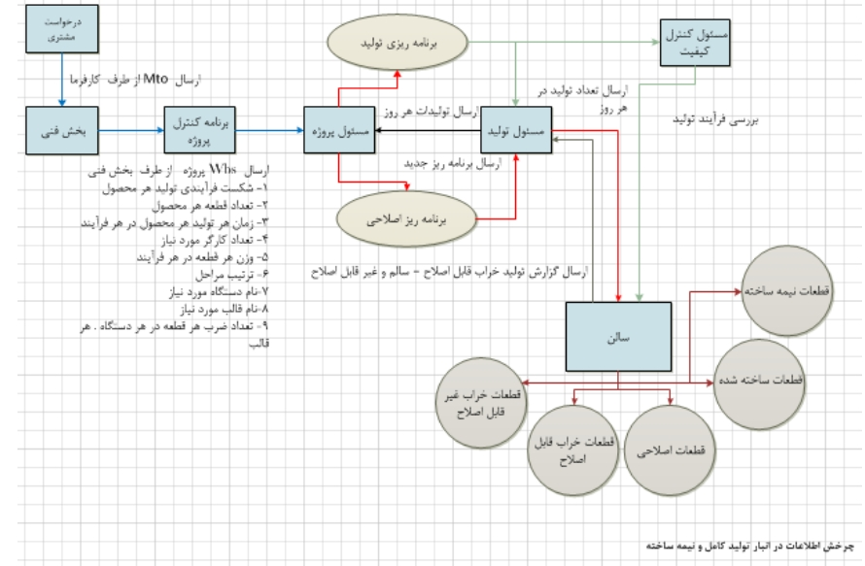

|  |  |  |  |  |  |
| --- | --- | --- | --- | --- | --- |
|  | **Alam Afrooz Production and Engineering Company** | | | | AlamAfroze Co. |
|  | Title Deed Number | Quality Control Guidelines | Title of the document | Page:6 of 23 |
|  | Date |  | Revision Number |

Structure of Pre-production, Production and Delivery of Items

Project Manager:

After the start of the project and the closing of the contract, the work structure is as follows:

1. Project MTO Submission
2. Send Project Start Letter
3. Sending Employer-Approved Executive Drawings
4. Sending production priorities (in case of employer pain)
5. WBS Project Products Document Submission
6. Overall Production Planning

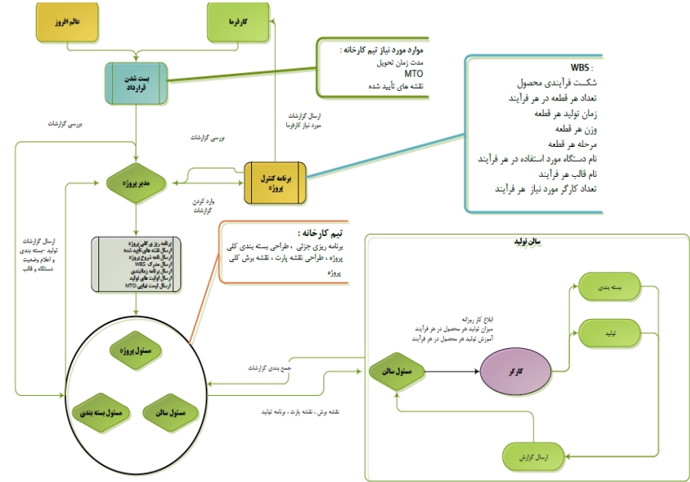

|  |  |  |  |  |  |
| --- | --- | --- | --- | --- | --- |
|  | **Alam Afrooz Production and Engineering Company** | | | | AlamAfroze Co. |
|  | Title Deed Number | Quality Control Guidelines | Title of the document | Page:7 of 23 |
|  | Date |  | Revision Number |

After sending the documents to the factory, the following will be prepared and implemented:

0. Partial planning

2. Packaging Design – Large and Moving Items

9. Cutting Map Design

1. Part Drawing

Production Manager:

0. N Earth on Cutting Card – Part Map

2. Packing

9. Focus on manufacturing and production planning in the factory.

1. Exaggeration and implementation of telegrams in the project product drawings – production priorities

1. Emphasis on the final quality of the items.

1. The time of the prevention or probable legacy of devices and molds

Person in charge of the hall:

0. Divisions of labor among workers

2. The production of products

9. Control the production of the first product of each machine

1. Delivery of the items from the end of the worker's journey.

1. Record production, breakdown, and packaging reports

1. Insert the part drawing and cutting drawing on the machine

7. Mold and Mold Molding Machines

Packaging Officer

0. Preparing the packaging plan of the items.

2. Artwork on the packaging of the items

9. Installing the packing on the climate.

1. Counting and checking the quality of the items

|  |  |  |  |  |  |
| --- | --- | --- | --- | --- | --- |
|  | **Alam Afrooz Production and Engineering Company** | | | | AlamAfroze Co. |
|  | Title Deed Number | Quality Control Guidelines | Title of the document | Page:8 of 23 |
|  | Date |  | Revision Number |

Quality Control Steps

Pre-Production

Brasa Certified Map of Kafrma, the project manager prepares 2 maps:

0. Cutting Map: Based on this map, the method of cutting the sheet from the full sheet is determined.

2. Part Map: This map shows how the product is produced.

✓ The person in charge of the hall installs these drawings on the pan of the machine for the product that is on the line.

✓ Also, the machine will be checked before commissioning and if approved, the production process will take place.

✓ After going through these steps, the person in charge of the hall teaches the worker how to check the water and quality.

Start of production

After the start of work, the person in charge of the salon and the person in charge of quality control is obliged to have an art at the beginning of the work.

✓ 1 The first part is done by the production manager.

✓ Then the worker starts to produce and immediately check the map installed on the machine of his product and in case of

He puts aside the observation of the malaert and gives the production manager pain.

✓ Also, the person in charge of the hall at the end of each production of the product reviews the cutting map or part of the product.

The person in charge of the hall should investigate the reason after the pain of the failure and solve the problem immediately. Push downtime can be the following

Be:

-0 Worker Mistake

-2 Devices

9. Improper design of part drawings and cutting cards

After fixing the problem and giving pain to the project manager, he decides on two categories of failures:

-0 product is unsuitable.

A) It will be sent to the warehouse.

b) It becomes another product.

2. The product can be repaired.

|  |  |  |  |  |  |
| --- | --- | --- | --- | --- | --- |
|  | **Alam Afrooz Production and Engineering Company** | | | | AlamAfroze Co. |
|  | Title Deed Number | Quality Control Guidelines | Title of the document | Page:9 of 23 |
|  | Date |  | Revision Number |

**End of production**

At the end of the production of the products, the person in charge of the project will check the climate at the end of the day and if you want to buy the product for the

Reform or reproduction.

Non-compliant product identification:

In the event that any of the conformity tail production/assembly steps occur or are observed after conducting the conformity tail inspection and test,

The quality control market records and evaluates it and if possible separates it to the operator and then in coordination with the responsible

Production for the product is not compatible, this specification can include the following:

a) The non-conforming product is reworked so that its specifications are in accordance with the drawings and instructions of the process machines.

b) In case of the possibility of reworking, it will be separated.

c) It should be part of your waste and be sold.

d) It is used by obtaining a concession license from the competent authorities (management/customer).

If it is found that the shipment cannot be used after consolidation, it will be transferred to the red pallet that is located in the production hall.

and in the intervals of up to 01 days, your waste will be collected and collected.

|  |  |  |  |  |  |
| --- | --- | --- | --- | --- | --- |
|  | **Alam Afrooz Production and Engineering Company** | | | | AlamAfroze Co. |
|  | Title Deed Number | Quality Control Guidelines | Title of the document | Page:10 of 23 |
|  | Date |  | Revision Number |

**3. Quality Implementation and Archiving Method:**

The method of implementing the quality control procedures is as follows:

First, a zone called quality control of the production line is created to organize and track the records, which is

It is segregated monthly, and daily quality reports are completed and archived.

It should be noted that if the compliance tail is observed, the completed form will be attached to the file of the quality form on the same day.

First, at the beginning of production, 1 sample should be at the beginning of the line, and in case of a dispute, it will be started with the map.

According to the schedule for the large and small boats, which includes trays, ladders, and large supports, each

Samples will be taken (according to the approved map of the employer and the water drains of Tehrans) and the results in the following form will be separated by day.

Enters

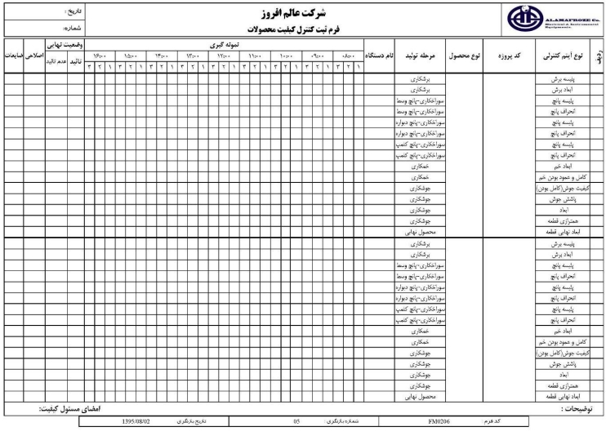

|  |  |  |  |  |  |
| --- | --- | --- | --- | --- | --- |
|  | **Alam Afrooz Production and Engineering Company** | | | | AlamAfroze Co. |
|  | Title Deed Number | Quality Control Guidelines | Title of the document | Page:11 of 23 |
|  | Date |  | Revision Number |

Filling out the form is like this: the date is entered first, and the number starts from 10, and on each page 9 products are entered.

and if you have a product of more than 9 dead, you must enter the additional data on another page and the number of the sheet

12.

If the tail is observed, the following form will be completed and the production manager will be informed, and the production line will be stopped until

Fix the problem

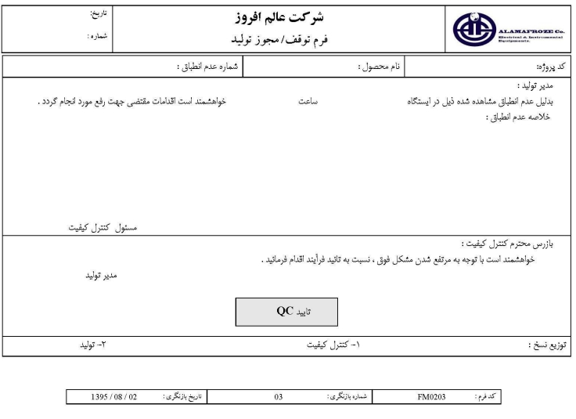

After the problem is resolved, the quality officer will be notified to check that if the problem is resolved, a license will be issued to start production.

.)The form below should be completed above.

The numbering of the production stoppage/production license form is as follows: it starts daily from the number 10 and ends at the end of the day.

The bill of account is added to the list of B-lists, and for day B-D it starts again from 10.